###### A

Major Project On

#### AUTOMATIC FALL DETECTION CAVITY FOR ELDERLY PEOPLE USING MEMS

(Submitted in partial fulfillment of the requirements for the award of Degree)

BACHELOR OF TECHNOLOGY

In

###### COMPUTER SCIENCE AND ENGINEERING

By

###### PEDDITI SATVIKA (197R1A05N7)

###### PARANKUSHAM VAISHNAVI (197R1A05N8)

###### MAMINDLA MOUNIKA (197R1A05M7)

Under the Guidance of

**Dr. K. SRUJAN RAJU**

(Professor of CSE)



##### DEPARTMENT OF COMPUTER SCIENCE AND ENGINEERING

**CMR TECHNICAL CAMPUS UGC AUTONOMOUS**

(Accredited by NAAC, NBA, Permanently Affiliated to JNTUH, Approved by AICTE, New Delhi) Recognized Under Section 2(f) & 12(B) of the UGCAct.1956, Kandlakoya (V), Medchal Road, Hyderabad-501401.

**2019-2023**

**DEPARTMENT OF COMPUTER SCIENCE AND ENGINEERING**



#### CERTIFICATE

This is to certify that the project entitled **“AUTOMATIC FALL DETECTION CAVITY FOR ELDERLY PEOPLE USING MEMS”** being submitted by **PEDDITI SATVIKA (197R1A05N7), PARANKUSHAM VAISHNAVI (197R1A05N8) & MAMINDLA MOUNIKA (197R1A05M7)** in partial fulfillment of the requirements for the award of the degree of B.Tech in Computer Science and Engineering to the Jawaharlal Nehru Technological University Hyderabad, is a record of bonafide work carried out by them under our guidance and supervision during the year 2022-23.

The results embodied in this thesis have not been submitted to any other University or Institute for the award of any degree or diploma.

**Dr. K. Srujan Raju Dr. A. Raji Reddy**

(Professor of CSE) DIRECTOR

INTERNAL GUIDE

**Dr. K. Srujan Raju EXTERNAL EXAMINER**

HOD

**Submitted for viva voice Examination held on**

##### ACKNOWLEDGEMENT

Apart from the efforts of us, the success of any project depends largely on the encouragement and guidelines of many others. We take this opportunity to express our gratitude to the people who have been instrumental in the successful completion of this project.

We take this opportunity to express my profound gratitude and deep regard to our guide **Dr. K. Srujan Raju,** Professor of CSE for his exemplary guidance, monitoring and constant encouragement throughout the project work. The blessing, help and guidance given by him shall carry us a long way in the journey of life on which we are about to embark.

We also take this opportunity to express a deep sense of gratitude to the Project Review Committee (PRC) **Dr. Punyaban Patel, Ms. Shilpa, Dr. M. Subha Mastan Rao & J. Narasimharao** for their cordial support, valuable information and guidance, which helped us in completing this task through various stages.

We are also thankful to **Dr. K. Srujan Raju,** Head, Department of Computer Science and Engineering for providing encouragement and support for completing this project successfully.

We are obliged to **Dr. A. Raji Reddy,** Director for being cooperative throughout the course of this project. We also express our sincere gratitude to Sri. **Ch. Gopal Reddy,** Chairman for providing excellent infrastructure and a nice atmosphere throughout the course of this project.

The guidance and support received from all the members of **CMR Technical Campus** who contributed to the completion of the project. We are grateful for their constant support and help.

Finally, we would like to take this opportunity to thank our family for their constant encouragement, without which this assignment would not be completed. We sincerely acknowledge and thank all those who gave support directly and indirectly in the completion of this project.

PEDDITI SATVIKA (197R1A05N7)

**PARANKUSHAM VAISHNAVI (197R1A05N8)**

**MAMINDLA MOUNIKA (197R1A05M7)**

##### ABSTRACT

Falling down is one among the major causes for medical problems that are faced by the elderly people. Elder people undergo the risk of serious harm due to fall. Many elderly people can suffer unintentional falls due to weakness or dizziness. The major consequences are not related to the falling, but rather due to unassisted or treated with delay. To provide better living for the elderly people and those with special assistance, it is necessary to develop a monitoring system which alerts the care givers of any emergency assistance. In this project, we propose to develop a low-cost fall detection system to precisely detect an event when an elderly person accidentally falls. The fall detection algorithm compares the acceleration with lower fall threshold and upper fall threshold values to accurately detect a fall event. The post-fall recognition module is the combination of posture recognition and vertical velocity estimation that has been added to our proposed method to enhance the performance and accuracy. In case of a fall, our device will display it on LCD and produces a voice alert. The data is then uploaded in the IOT server which is being monitored by the caretaker.

##### FIGURE NO FIGURE NAME PAGE NO

Table 2.5.1 Hardware Requirements 7

Figure 2.5.1.1 Arduino Uno 8

Figure 2.5.1.2 ESP8266 8

Figure 2.5.1.3 ADX1335 9

Figure 2.5.1.4 APR Module 10

###### Figure 3.1 Project Architecture for Automatic 11

###### Fall Detection Cavity For Elderly

###### People Using MEMs Sensor

###### Figure 3.2 Use Case Diagram for Automatic 12

###### Fall Detection Cavity For Elderly

###### People Using MEMs Sensor

###### 

###### Figure 3.3 Class Diagram for Automatic 13

###### Fall Detection Cavity For Elderly

###### People Using MEMs Sensor

###### 

###### Figure 3.4 Sequence diagram for Automatic 14

###### Fall Detection Cavity For Elderly

###### People Using MEMs Sensor

###### 

###### Figure 3.5 Activity diagram for Automatic 15

###### Fall Detection Cavity For Elderly

###### People Using MEMs Sensor

##### FIGURE NO FIGURE NAME PAGE NO

###### Figure 5.1 Automatic Fall Detection device 32

###### Figure 5.2 Switching on the power supply 33

###### Figure 5.3 Connecting to wifi 34

###### Figure 5.4 Device connected to wifi 35

###### Figure 5.5 Device in stable condition 36

###### Figure 5.6 Front Fall Detected 37

###### Figure 5.7 Back Fall Detected 38

###### Figure 5.8 Right Fall Detected 39

###### Figure 5.9 Left Fall Detected 40

###### 

###### 

**LIST OF SCREENSHOTS**

##### SCREENSHOT NO SCREENSHOT NAME PAGE NO

###### Screenshot 5.1 Login page 41

###### Screenshot 5.2 Entering Login Credentials 42

###### Screenshot 5.3 Iot Server Page 43

###### 

ABSTRACT i

LIST OF FIGURES ii

1. INTRODUCTION 
   1. PROJECT SCOPE 1
   2. PROJECT PURPOSE 1
   3. PROJECT FEATURES 1
2. SYSTEM ANALYSIS 
   1. PROBLEM DEFINITION 2
   2. EXISTING SYSTEM 2
      1. LIMITATIONS OF THE EXISTING SYSTEM 3
   3. PROPOSED SYSTEM 3
      1. ADVANTAGES OF PROPOSED SYSTEM 4
   4. FEASIBILITY STUDY 5
      1. ECONOMIC FEASIBILITY 5
      2. TECHNICAL FEASIBILITY 6
      3. BEHAVIORAL FEASIBILITY 6
   5. HARDWARE & SOFTWARE REQUIREMENTS 7
      1. HARDWARE REQUIREMENTS 7
      2. SOFTWARE REQUIREMENTS 10
3. ARCHITECTURE 
   1. PROJECT ARCHITECTURE 11
   2. DESCRIPTION 11
   3. USE CASE DIAGRAM 12
   4. CLASS DIAGRAM 13
   5. SEQUENCE DIAGRAM 14
   6. ACTIVITY DIAGRAM 15
4. IMPLEMENTATION 
   1. SOURCE CODE 16
5. RESULTS 32
6. TESTING 
   1. INTRODUCTION TO TESTING 44
   2. TYPES OF TESTING 44
      1. UNIT TESTING 44
      2. INTEGRATION TESTING 45
      3. FUNCTIONAL TESTING 45
   3. TEST CASES 46
      1. CLASSIFICATION 46
7. CONCLUSION & FUTURE SCOPE
   1. PROJECT CONCLUSION 47
   2. FUTURE SCOPE 47
8. REFERENCES
   1. REFERENCES 48
   2. GITHUB LINK 48

**9. PAPER PUBLICATION** 49

**10. CERTIFICATES** 48

# 

# 1. INTRODUCTION

#### INTRODUCTION

##### PROJECT SCOPE

This project is titled “Automatic fall detection cavity for elderly people using mems”. With elderly who live alone, not being found for hours after a fall is quite common and drastically increases the significance of fall-induced injuries. With an aging baby Boomer population, the incidence of falls will only rise in the next few decades. The objective of this project was to design and create a fall detection and prevention system for the elderly. It can notify the concerned person or family member whenever it detects any fall and can reduce the risk of delayed medical attention. This has led to the development of automated fall detection systems.

##### PROJECT PURPOSE

This project has been designed to develop an intelligent, reliable and cost efficient fall detection and alert system and a fall detection system that is user friendly and without causing disturbance to activities of daily living of elderly people.

##### PROJECT FEATURES

In this project the MEMS sensor includes built-in features such as free fall, wake up, tap, motion/stationary and activity/inactivity detection with two flexible interrupt pins. These features reduce the complex algorithm development effort one needs for the fall detection systems. The combination of these in-built features could detect the fall of a person which makes the ADXL335 3-axis acceleration sensor suitable for this application. The built-in features prohibit the requirement to access the acceleration data continuously from the sensor in order to perform complex computations to realize a fall detection system.

## SYSTEM ANALYSIS

##### SYSTEM ANALYSIS

**SYSTEM ANALYSIS**

System Analysis is the important phase in the system development process. The System is studied to the minute details and analyzed. The system analyst plays an important role of an interrogator and dwells deep into the working of the present system. In analysis, a detailed study of these operations performed by the system and their relationships within and outside the system is done. A key question considered here is, “what must be done to solve the problem?” The system is viewed as a whole and the inputs to the system are identified. Once analysis is completed the analyst has a firm understanding of what is to be done.

##### PROBLEM DEFINITION

According to a report published by World Health Organization, early fall detection is an active problem in the old age group people. The report revealed that the fall detection problem affect 28-35% people for the people around 65 years of age and 32-45% for those over 70 years. Objective of our project is to develop a system to provide a timely medical assistance to an old age person in case of fall. Early detection of fall could not only minimize the damage in terms of head, spinal or any similar major bone injuries but also provide timely assistance thereby saving efforts and money.

##### 2.2 EXISTING SYSTEM

Floor vibration based fall detection system consists of vibration-based floor detectors, using a piezoelectric sensor fixed to the floor surface of a room by means of a mass and spring arrangement. Visual based fall detection system uses vision-based approach and multivariate exponentially weighted moving average (MEWMA) scheme to detect a fall. The user is monitored through installed cameras and a fall or not fall decision is made based on four major steps of the algorithm.

Smart textile based fall detection system uses the smart textile by Hexoskin, Carré technology, which enables real-time remote monitoring of 3D acceleration data using three-axis sensors, cardiac activity, and respiratory activity on smartphones and tablets using Bluetooth.

**2.2.1 DISADVANTAGES OF EXISTING SYSTEM**

* It is only suitable for indoor areas.
* Privacy intrusion due to vision based fall detection.
* High false rate alarm.

##### PROPOSED SYSTEM

The problems mentioned in the existing system can be overcome using this proposed system. This system provides an alert to the care takers or other people about the fall occurrence of the elderly people or person who needs to be monitored. Here micro controller is known as the heart of the entire system. In this system an MEMS Accelerometer is used, which will detect the fall of elderly person. The Accelerometer is able to measure the static acceleration and dynamic acceleration of gravity in sensing applications and shock or vibration respectively. Here we have used the ADXL335 which is a 3-axis accelerometer sensor which has analog output with ±3g measurement range. It also has predetermined threshold axis values. If the acceleration of the body condition exceeds the threshold value, the system will recognize the fall condition. On detecting the fall of the person, an intimation message can be sent through IOT module implemented with controller. Once the system is implemented, the care taker will get the user name and password for IOT data access. Also a voice alert is given so that anyone from surroundings can help.

2.3.1 ADVANTAGES OF THE PROPOSED SYSTEM

* Immediate fall alert can be given.
* Continuous Health condition monitoring system is available.
* Alert message is given through IOT
* Date and time will be uploaded to cloud for future reference

* 1. **FEASIBILITY STUDY**

The feasibility of the project is analyzed in this phase and a business proposal is put forth with a very general plan for the project and some cost estimates. During system analysis the feasibility study of the proposed system is to be carried out. This is to ensure that the proposed system is not a burden to the company. Three key considerations involved in the feasibility analysis:

* Economic Feasibility
* Technical Feasibility
* Behavioral Feasibility

2.4.1 ECONOMIC FEASIBILITY

The developing system must be justified by cost and benefit. Criteria to ensure that effort is concentrated on a project, which will give best, return at the earliest. One of the factors, which affect the development of a new system, is the cost it would require.

The following are some of the important financial questions asked during preliminary investigation:

* The costs conduct a full system investigation.
* The cost of the hardware and software.
* The benefits in the form of reduced costs or fewer costly errors.

Since the system is developed as part of project work, there is no manual cost to spend for the proposed system. Also all the resources are already available, it give an indication that the system is economically possible for development.

* + 1. TECHNICAL FEASIBILITY

This project is carried out to check the technical feasibility, that is, the technical requirements of the system. Any system developed must not have a high demand on the available technical resources. The developed system must have a modest requirement, as only minimal or null changes are required for implementing this system.

* + 1. BEHAVIORAL FEASIBILITY

This includes the following questions:

* Is there sufficient support for the users?
* Will the proposed system cause harm?

The project would be beneficial because it satisfies the objectives when developed and installed. All behavioral aspects are considered carefully and conclude that the project is behaviorally feasible

**2.5 HARDWARE & SOFTWARE REQUIREMENTS**

2.5.1 HARDWARE REQUIREMENTS:

Hardware interfaces specify the logical characteristics of each interface between the software product and the hardware components of the system. The following are some hardware requirements.

|  |  |
| --- | --- |
| **MATERIAL** | **QUANTITY** |
| ARDUINO UNO | 1 |
| ESP8266 | 1 |
| ADXL335 | 1 |
| APR MODULE | 1 |
| CRYSTAL |  |
| LCD(16X2 LCD) | 1 |
| POWER SOURCE | - |

Table 2.5.1 Hardware Requirements

**2.5.1.1 Arduino Uno:**

The Arduino Uno is a microcontroller board based on the ATmega328 ([datasheet](http://www.atmel.com/dyn/resources/prod_documents/doc8161.pdf)). It has 14 digital input/output pins (of which 6 can be used as PWM outputs), 6 analog inputs, a 16 MHz ceramic resonator, a USB connection, a power jack, an ICSP header, and a reset button.

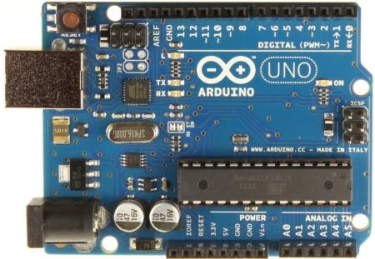

Figure 2.5.1.1 Arduino uno

**2.5.1.2 ESP8266:**

ESP8266 is an impressive, low cost WiFi module suitable for adding WiFi functionality to an existing microcontroller project via a UART serial connection. The module can even be reprogrammed to act as a standalone WiFi connected device–just add power

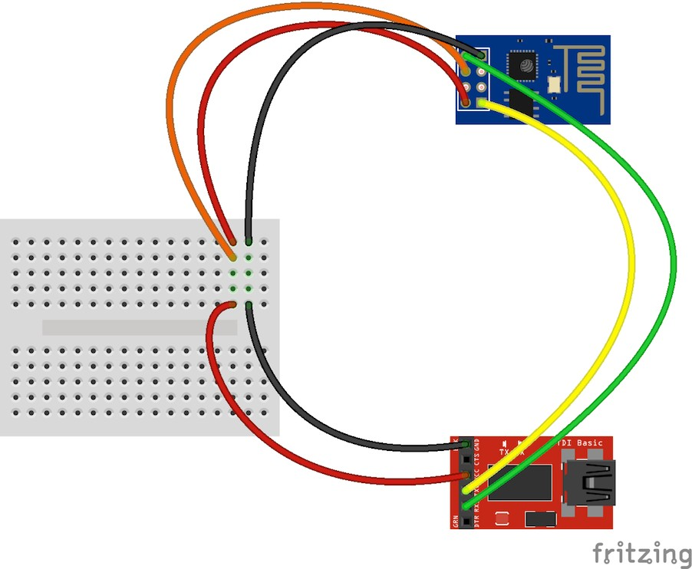

Figure 2.5.1.2 ESP8266

**2.5.1.3 ADXL335:**

The ADXL335 is a small, thin, low power, complete 3-axis accel> erometer with signal conditioned voltage outputs. The product measures acceleration with a minimum full-scale range of z3 g. lt can measure the static acceleration of gravity in tilt-sensing applications, as well as dynamic acceleration resulting from motion, shock, or vibration.

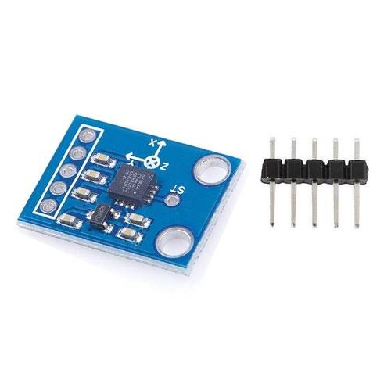

Figure 2.5.1.3 ADXl335

**2.5.1.4 APR MODULE:**

The APR9600 device offers true single-chip voice recording, non-volatile storage, and playback capability for 40 to 60 seconds. The device supports both random and sequential access of multiple messages. Sample rates asire user-selectable, allowing designers to customize their design for unique quality and storage time needs.

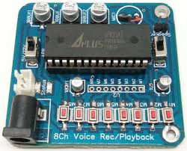

Figure 2.5.1.4:APR MODULE

##### 2.5.2 SOFTWARE REQUIREMENTS:

Software Requirements specifies the logical characteristics of each interface and software components of the system. The following are some software requirements,

* IDE: Arduino IDE
* Languages: Embedded C, CPP

## 

## 3. ARCHITECTURE

##### 3. ARCHITECTURE

##### PROJECT ARCHITECTURE

This project architecture shows the procedure followed for classification, starting from input to final prediction.

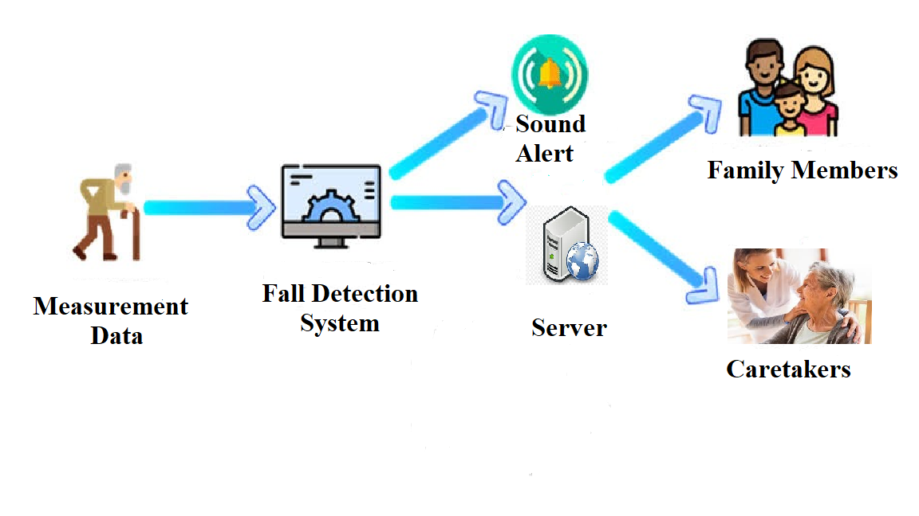

Figure 3.1: Project Architecture of Automatic fall detection

cavity for elderly people using mems sensor

* 1. DESCRIPTION

In this project an MEMS Accelerometer is used, which will detect the fall of elderly person. The Accelerometer is able to measure the static acceleration and dynamic acceleration of gravity in sensing applications and shock or vibration respectively. Here we have used the ADXL335 is a 3-axis accelerometer sensor which has analog output with ±3g measurement range. It also has pre-determined threshold axis values. If the acceleration of the body condition exceeds the threshold value, the system will recognize the fall condition. On detecting the fall of the person, an intimation message can be sent through IOT module implemented with controller. Once the system is implemented, the care taker will get the user name and password for IOT data access. Intimation message will be sent to the care taker mobile number which is dumped already with the controller code.

3.3 USE CASE DIAGRAM

In the use case diagram, we have basically one actor who is the user in the trained model.

A use case diagram is a graphical depiction of a user's possible interactions with a system. A use case diagram shows various use cases and different types of users

the system has. The use cases are represented by either circles or ellipses. The actors are often shown as stick figures.

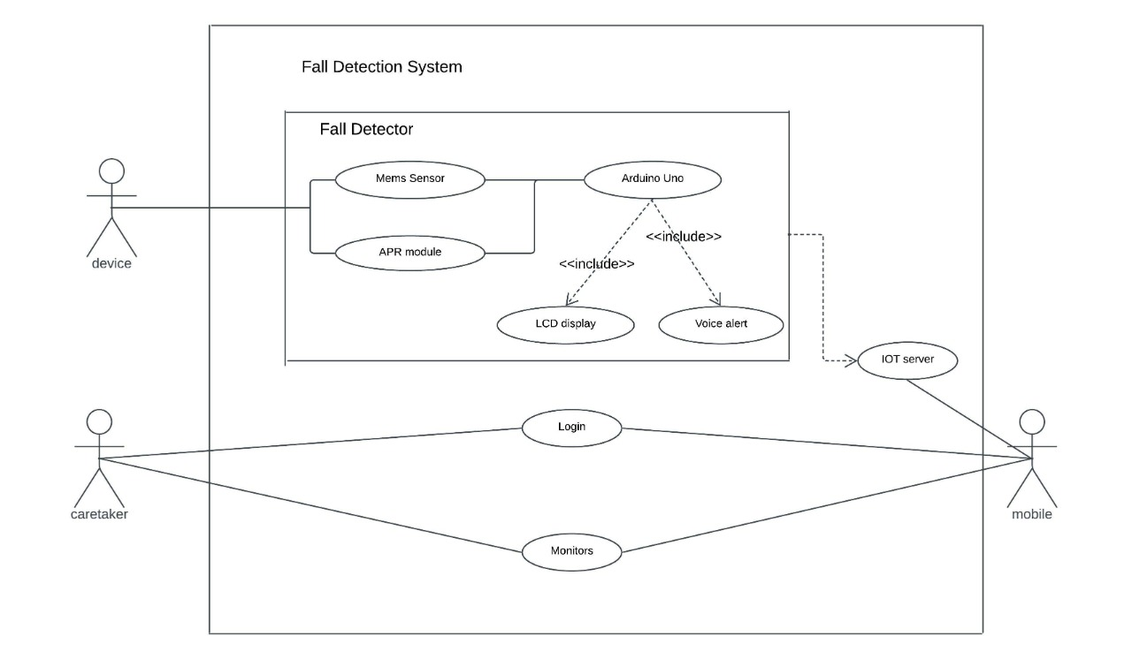

Figure 3.2: Use Case Diagram for Automatic fall detection cavity for elderly people using mems.

##### 3.4 CLASS DIAGRAM

Class diagram is a type of static structure diagram that describes the structure

of a system by showing the system’s classes, their attributes, operations (or methods), and the relationships among objects.

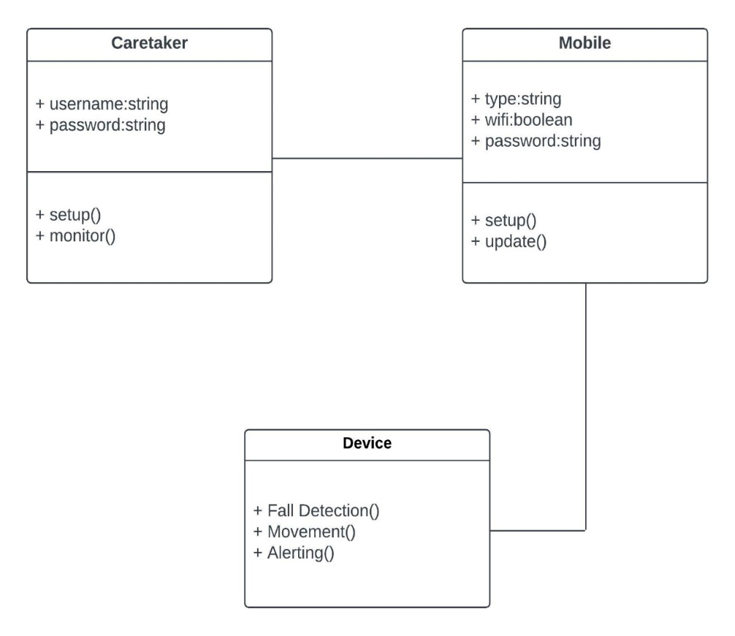

Figure 3.3: Class Diagram for Automatic fall detection cavity for elderly people using mems.

##### 3.5 SEQUENCE DIAGRAM

A sequence diagram shows object interactions arranged in time sequence. It depicts the objects involved in the scenario and the sequence of messages exchanged between the objects needed to carry out the functionality of the scenario. Sequence diagrams are typically associated with use case realizations in the logical view of the system under development.

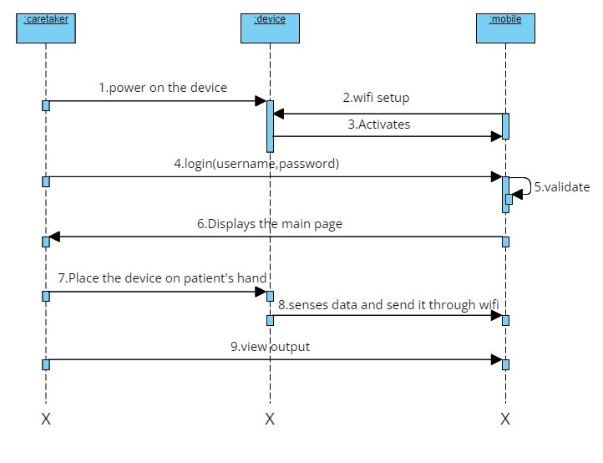

Figure 3.4: Sequence Diagram for Automatic fall detection cavity for elderly people using mems.

3.6 ACTIVITY DIAGRAM

Activity diagrams are graphical representations of workflows of stepwise activities and actions with support for choice, iteration and concurrency. They can also include elements showing the flow of data between activities through one or more data stores. 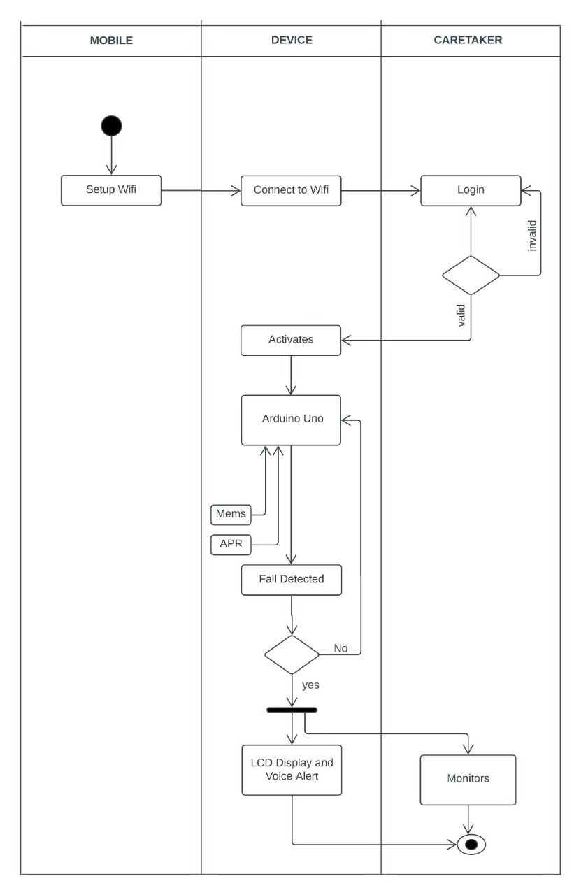 Figure 3.5: Activity diagram for Automatic fall detection cavity for elderly people using mems

**4. IMPLEMENTATION**

**4.1 SOURCE CODE**

#include <LiquidCrystal.h>

LiquidCrystal lcd(6,7,5,4,3,2);

#include <Wire.h>

#include <SoftwareSerial.h>

SoftwareSerial mySerial(8,9);

int ADXL345 = 0x53;

float X_out, Y_out, Z_out;

int memsx=0,memsy=0;

int voice1 = 10;

int voice2 = 11;

int voice3 = 12;

int voice4 = 13;

int buzzer = A3;

char rcv,pastnumber[11];

char res[130];

void adxl_345_init()

{

Wire.begin(); // Initiate the Wire library

// Set ADXL345 in measuring mode

Wire.beginTransmission(ADXL345); // Start communicating with the device

Wire.write(0x2D); // Access/ talk to POWER_CTL Register - 0x2D

// Enable measurement

Wire.write(8); // (8dec -> 0000 1000 binary) Bit D3 High for measuring enable

Wire.endTransmission();

delay(10);

}

void adxl_345_read()

{

// === Read acceleromter data === //

Wire.beginTransmission(ADXL345);

Wire.write(0x32); // Start with register 0x32 (ACCEL_XOUT_H)

Wire.endTransmission(false);

Wire.requestFrom(ADXL345, 6, true); // Read 6 registers total, each axis value is stored in 2 registers

X_out = ( Wire.read()| Wire.read() << 8); // X-axis value

//X_out = X_out/256; //For a range of +-2g, we need to divide the raw values by 256, according to the datasheet

Y_out = ( Wire.read()| Wire.read() << 8); // Y-axis value

//Y_out = Y_out/256;

Z_out = ( Wire.read()| Wire.read() << 8); // Z-axis value

//Z_out = Z_out/256;

/*

Serial.print("Xa= ");

Serial.print(X_out);

Serial.print(" Ya= ");

Serial.print(Y_out);

Serial.print(" Za= ");

Serial.println(Z_out);

*/

}

void serialFlush()

{

while(Serial.available() > 0)

{

char t = Serial.read();

}

}

void myserialFlush()

{

while(mySerial.available() > 0)

{

char t = mySerial.read();

}

}

char check(char* ex,int timeout)

{

int i=0;

int j = 0,k=0;

while (1)

{

sl:

if(mySerial.available() > 0)

{

res[i] = mySerial.read();

if(res[i] == 0x0a || res[i]=='>' || i == 100)

{

i++;

res[i] = 0;

break;

}

i++;

}

j++;

if(j == 30000)

{

k++;

// Serial.println("kk");

j = 0;

}

if(k > timeout)

{

//Serial.println("timeout");

return 1;

}

}//while 1

if(!strncmp(ex,res,strlen(ex)))

{

// Serial.println("ok..");

return 0;

}

else

{

// Serial.print("Wrong ");

// Serial.println(res);

i=0;

goto sl;

}

}

char buff[200],k=0;

void upload(unsigned int s1,unsigned int s2,unsigned int s3);

char readserver(void);

void clearserver(void);

const char* ssid = "iotserver";

const char* password = "iotserver123";

int sti=0;

String inputString = ""; // a string to hold incoming data

boolean stringComplete = false; // whether the string is complete

void okcheck()

{

unsigned char rcr;

do{

rcr = Serial.read();

}while(rcr != 'K');

}

void setup()

{

char ret;

pinMode(voice1, OUTPUT);

pinMode(voice2, OUTPUT);

pinMode(voice3, OUTPUT);

pinMode(voice4, OUTPUT);

pinMode(buzzer, OUTPUT);

digitalWrite(buzzer, HIGH);

digitalWrite(voice1, HIGH);

digitalWrite(voice2, HIGH);

digitalWrite(voice3, HIGH);

digitalWrite(voice4, HIGH);

Serial.begin(9600);

mySerial.begin(9600);

// adxl_345_init();

//Vehicle tracking using IOT

lcd.begin(16,2);

lcd.clear();

lcd.setCursor(0, 0);lcd.print(" Automatic Fall");

lcd.setCursor(0, 1);lcd.print(" Detection");

delay(2500);

wifiinit();

delay(2500);

lcd.clear();

lcd.print("MEMS:");

}

char bf3[50];

int g=0,f=0,count=0,lc=0;

int cntlmk=0;

void loop()

{

memsx = analogRead(A0);

// lcd.setCursor(0,0);

// convertl(memsx);

delay(100);

memsy = analogRead(A1);

// lcd.setCursor(0,1);

// convertl(memsy);

delay(100);

// adxl_345_read();

if((memsx > 300 && memsx < 370) && (memsy > 300 && memsy < 370))

//if((X_out > -200 && X_out < 200) && (Y_out > -200 && Y_out < 200))

{

lcd.setCursor(5,0);

lcd.print("Stable ");

digitalWrite(voice1, HIGH);

digitalWrite(voice2, HIGH);

digitalWrite(voice3, HIGH);

digitalWrite(voice4, HIGH);

}

if((memsx < 300) && (memsy > 300 && memsy < 370))

//if((X_out < -200) && (Y_out > -200 && Y_out < 200))

{

lcd.setCursor(5,0);

lcd.print("Front-Fall ");

digitalWrite(voice1, LOW);

delay(3000);

digitalWrite(voice1, HIGH);

delay(500);

upload("Front-Fall");

}

if((memsx > 370) && (memsy > 300 && memsy < 370))

//if((X_out > 200) && (Y_out > -200 && Y_out < 200))

{

lcd.setCursor(5,0);

lcd.print("Back-Fall ");

digitalWrite(voice2, LOW);

delay(3000);

digitalWrite(voice2, HIGH);

delay(500);

upload("Back-Fall");

}

if((memsy < 300) && (memsx > 300 && memsx < 370))

//if((X_out > -200 && X_out < 200) && (Y_out < -200))

{

lcd.setCursor(5,0);

lcd.print("Left-Fall ");

digitalWrite(voice3, LOW);delay(3000);digitalWrite(voice3, HIGH);delay(500);

upload("Left-Fall");

}

if((memsy > 370) && (memsx > 300 && memsx < 370))

//if((X_out > -200 && X_out < 200) && (Y_out > 200))

{

lcd.setCursor(5,0);

lcd.print("Right-Fall ");

digitalWrite(voice4, LOW);

delay(3000);

digitalWrite(voice4, HIGH);

delay(500);

upload("Right-Fall");

}

}

void serialEvent()

{

while (Serial.available())

{

char inChar = (char)Serial.read();

if(inChar == '@')

{

sti=1;

}

if(sti == 1)

{

inputString += inChar;

}

if(inChar == '#')

{

sti=0;

stringComplete = true;

}

}

}

char bf2[50];

void upload(const char *s1)

{

delay(2000);

lcd.setCursor(15, 1);

lcd.print("U");

myserialFlush();

mySerial.println("AT+CIPSTART=4,\"TCP\",\"projectsfactoryserver.in\",80");

//http://projectsfactoryserver.in/storedata.php?name=pf5&s1=25&s2=35

//sprintf(buff,"GET http://embeddedspot.top/iot/storedata.php?name=iot139&s1=%u&s2=%u&s3=%u\r\n\r\n",s1,s2);

delay(8000);

//https://projectsfactoryserver.in/storedata.php?name=iotgps&lat=17.167898&lan=79.785643

memset(buff,0,strlen(buff));

sprintf(buff,"GET http://projectsfactoryserver.in/storedata.php?name=iot81&s1=%s\r\n\r\n",s1);

// memset(buff,0,strlen(buff));

// sprintf(buff,"GET http://projectsfactoryserver.in/storedata.php?name=iot4&s1=%s\r\n\r\n",s1);

myserialFlush();

sprintf(bf2,"AT+CIPSEND=4,%u",strlen(buff));

mySerial.println(bf2);

delay(5000);

myserialFlush();

mySerial.print(buff);

delay(2000);

mySerial.println("AT+CIPCLOSE");

lcd.setCursor(15, 1);

lcd.print(" ");

}

char readserver(void)

{

char t;

delay(2000);

lcd.setCursor(15, 1);

lcd.print("R");

myserialFlush();

mySerial.println("AT+CIPSTART=4,\"TCP\",\"projectsfactoryserver.in\",80");

//http://projectsfactoryserver.in/last.php?name=amvi001L

delay(8000);

memset(buff,0,strlen(buff));

sprintf(buff,"GET <http://projectsfactoryserver.in/last.php?name=iot4L\r\n\r\n>");

myserialFlush();

sprintf(bf2,"AT+CIPSEND=4,%u",strlen(buff));

mySerial.println(bf2);

delay(5000);

myserialFlush();

mySerial.print(buff);

//read status

while(1)

{

while(!mySerial.available());

t = mySerial.read();

// Serial.print(t);

if(t == '*' || t == '#')

{

if(t == '#')return 0;

while(!mySerial.available());

t = mySerial.read();

// Serial.print(t);

delay(1000);

myserialFlush();

return t;

}

}

delay(2000);

mySerial.println("AT+CIPCLOSE");

lcd.setCursor(15, 1);

lcd.print(" ");

delay(2000);

return t;

}

void clearserver(void)

{

delay(2000);

lcd.setCursor(15, 1);

lcd.print("C");

myserialFlush();

mySerial.println("AT+CIPSTART=4,\"TCP\",\"projectsfactoryserver.in\",80");

//sprintf(buff,"GET <http://projectsfactoryserver.in/storedata.php?name=iot1&s10=0\r\n\r\n>");

delay(8000);

memset(buff,0,strlen(buff));

sprintf(buff,"GET <http://projectsfactoryserver.in/storedata.php?name=iot4&s10=0\r\n\r\n>");

myserialFlush();

sprintf(bf2,"AT+CIPSEND=4,%u",strlen(buff));

mySerial.println(bf2);

delay(5000);

myserialFlush();

mySerial.print(buff);

delay(2000);

myserialFlush();

mySerial.println("AT+CIPCLOSE");

lcd.setCursor(15, 1);

lcd.print(" ");

delay(2000);

}

void wifiinit()

{

char ret;

st:

mySerial.println("ATE0");

ret = check((char*)"OK",50);

mySerial.println("AT");

ret = check((char*)"OK",50);

if(ret != 0)

{

delay(1000);

goto st;

}

lcd.clear();

lcd.setCursor(0, 0);

lcd.print("CONNECTING");

mySerial.println("AT+CWMODE=1");

ret = check((char*)"OK",50);

cagain:

myserialFlush();

mySerial.print("AT+CWJAP=\"");

mySerial.print(ssid);

mySerial.print("\",\"");

mySerial.print(password);

mySerial.println("\"");

if(check((char*)"OK",300))goto cagain;

mySerial.println("AT+CIPMUX=1");

delay(1000);

lcd.clear();

lcd.setCursor(0, 0);

lcd.print("WIFI READY");

}

void convertl(unsigned int value)

{

unsigned int a,b,c,d,e,f,g,h;

a=value/10000;

b=value%10000;

c=b/1000;

d=b%1000;

e=d/100;

f=d%100;

g=f/10;

h=f%10;

a=a|0x30;

c=c|0x30;

e=e|0x30;

g=g|0x30;

h=h|0x30;

// lcd.write(a);

// lcd.write(c);

lcd.write(e);

lcd.write(g);

lcd.write(h);

void convertk(unsigned int value)

{

unsigned int a,b,c,d,e,f,g,h;

a=value/10000;

b=value%10000;

c=b/1000;

d=b%1000;

e=d/100;

f=d%100;

g=f/10;

h=f%10;

a=a|0x30;

c=c|0x30;

e=e|0x30;

g=g|0x30;

h=h|0x30;

// lcd.write(a);

// lcd.write(c);

// lcd.write(e);

lcd.write(g);

lcd.write(h);

}

## 

## 

## 5.RESULTS

## 

## 

Figure 5.1 Automatic Fall Detection Device

## Description: This is Automatic Fall Detection Device. It has a Aurdino uno, Mems sensor, APR voice module, LCD display which are connected for the purpose of fall detection.

32

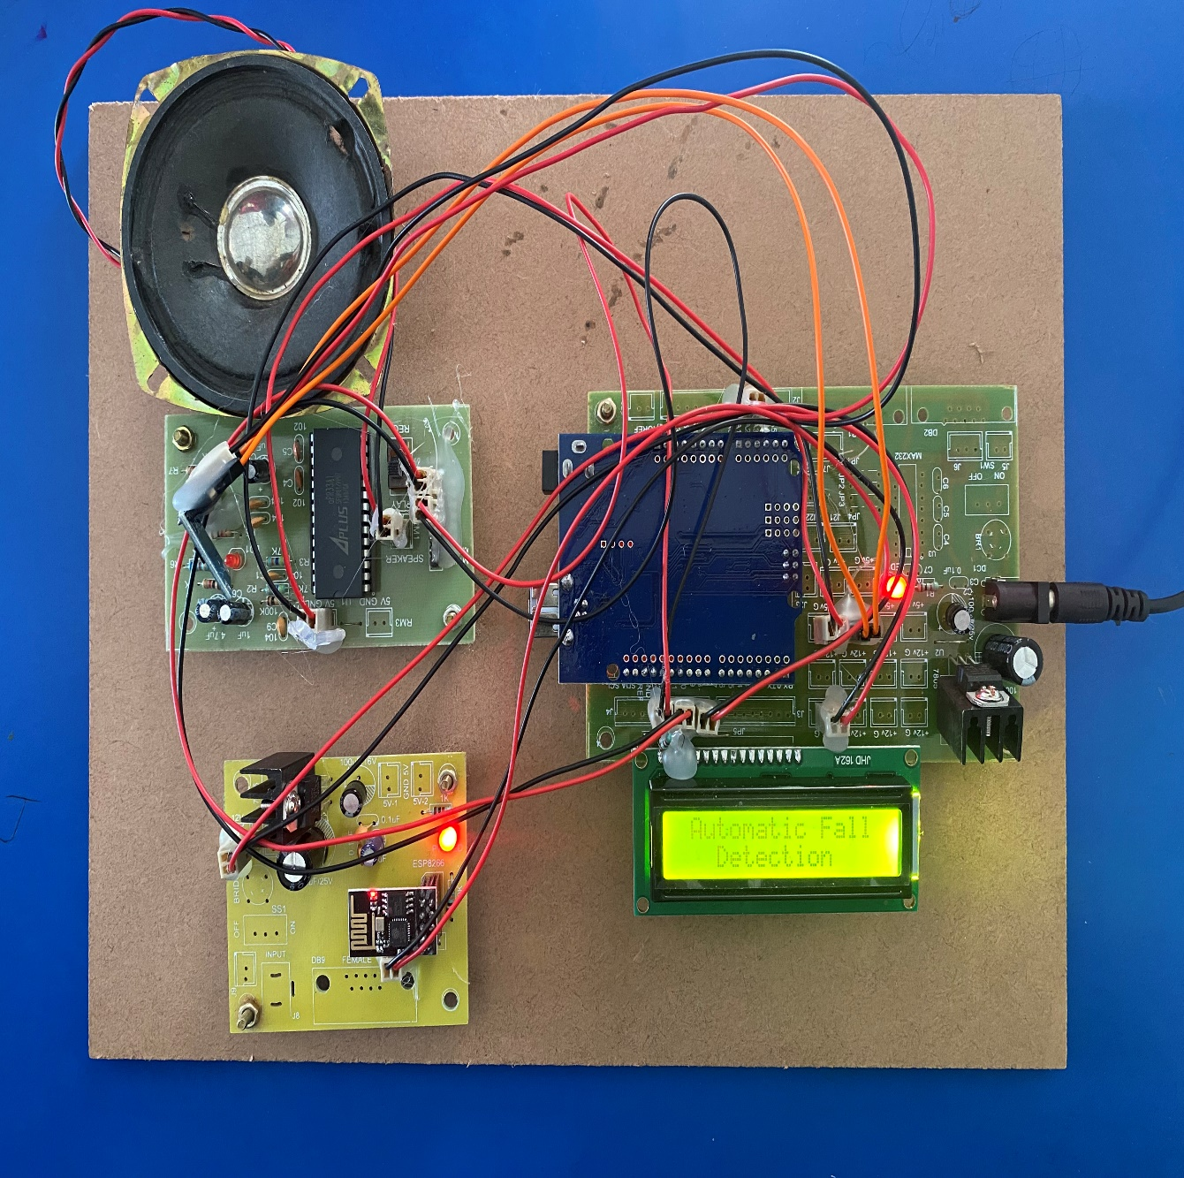

Figure 5.2 Switching on the power supply

## Description: As soon as the device is connected to a power supply there will be a message “Automatic Fall Detection” displayed on the LCD.

33

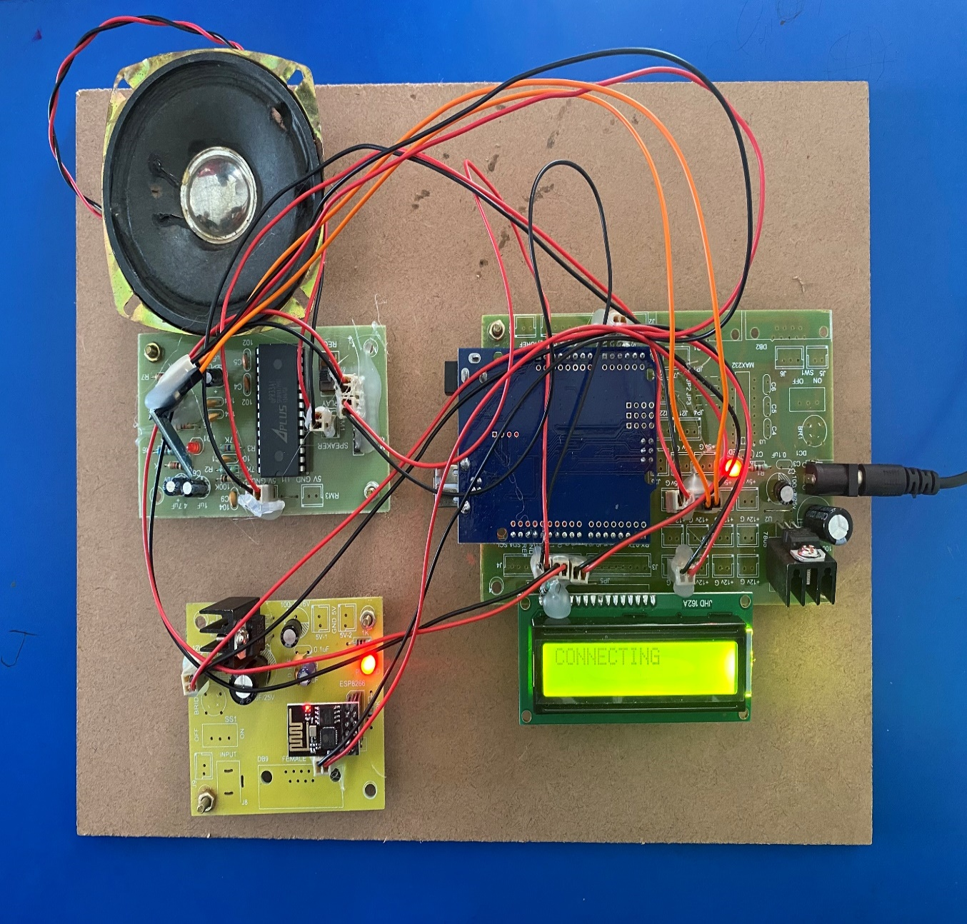

Figure 5.3 Connecting to wifi

**Description:** As soon as the device is powered on it waits for the internet connection.

34

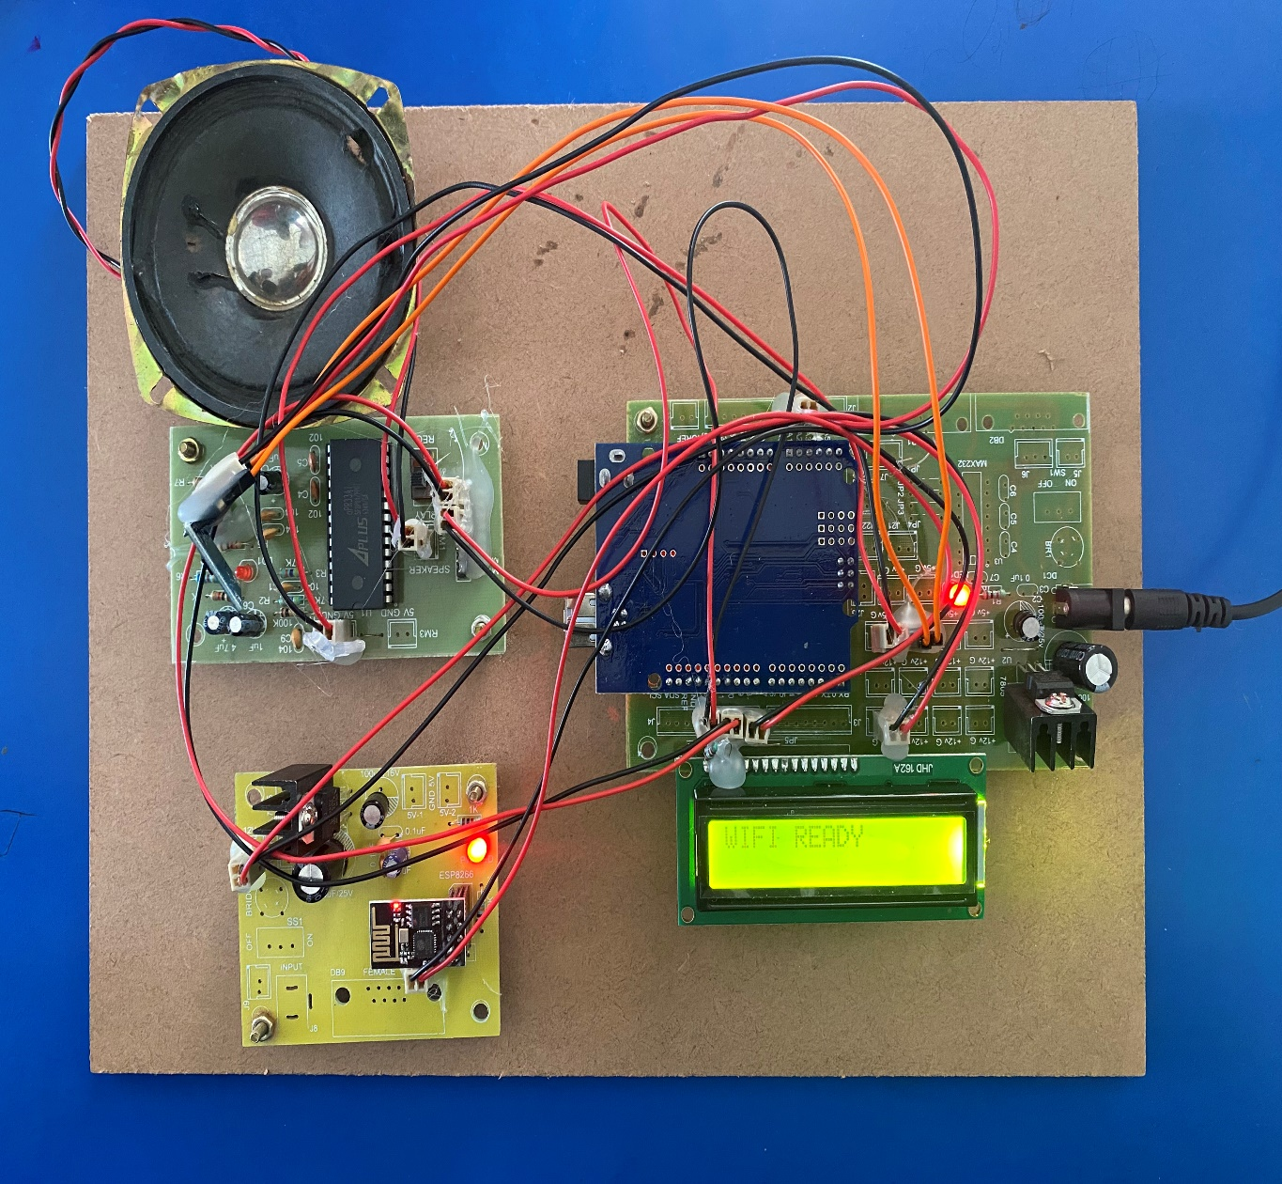

Figure 5.4 Device connected to wifi

**Description:** Device is connected to wifi when we on the hotspot on our mobile phone and a message “Wifi Ready” will be displayed on the LCD.

35

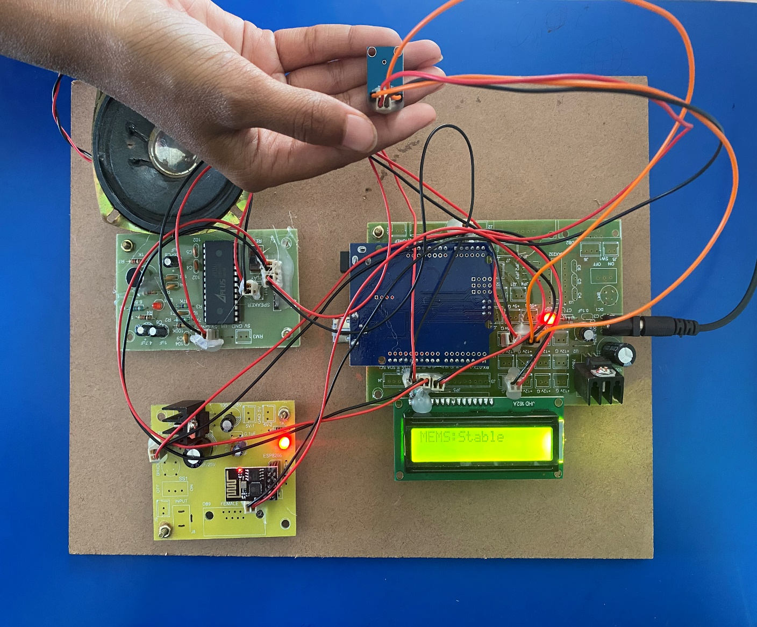

Figure 5.5 Device in stable condition

**Description**: When there is no movement the sensor will be in stable condition.

36

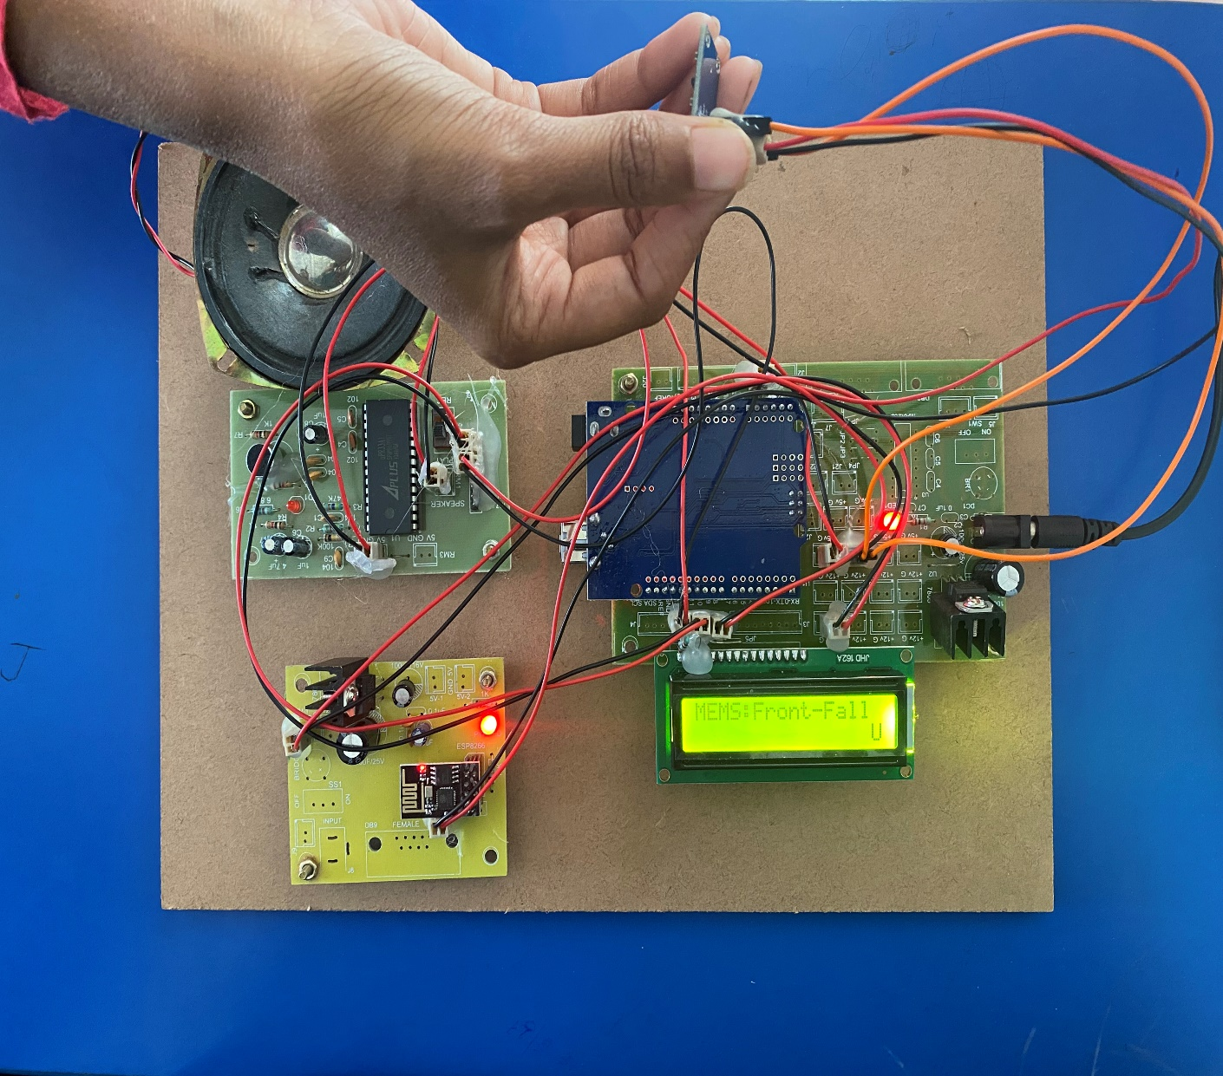

Figure 5.6 Front Fall Detected

**Description:** When a person falls forward then the sensor detects front fall.

37

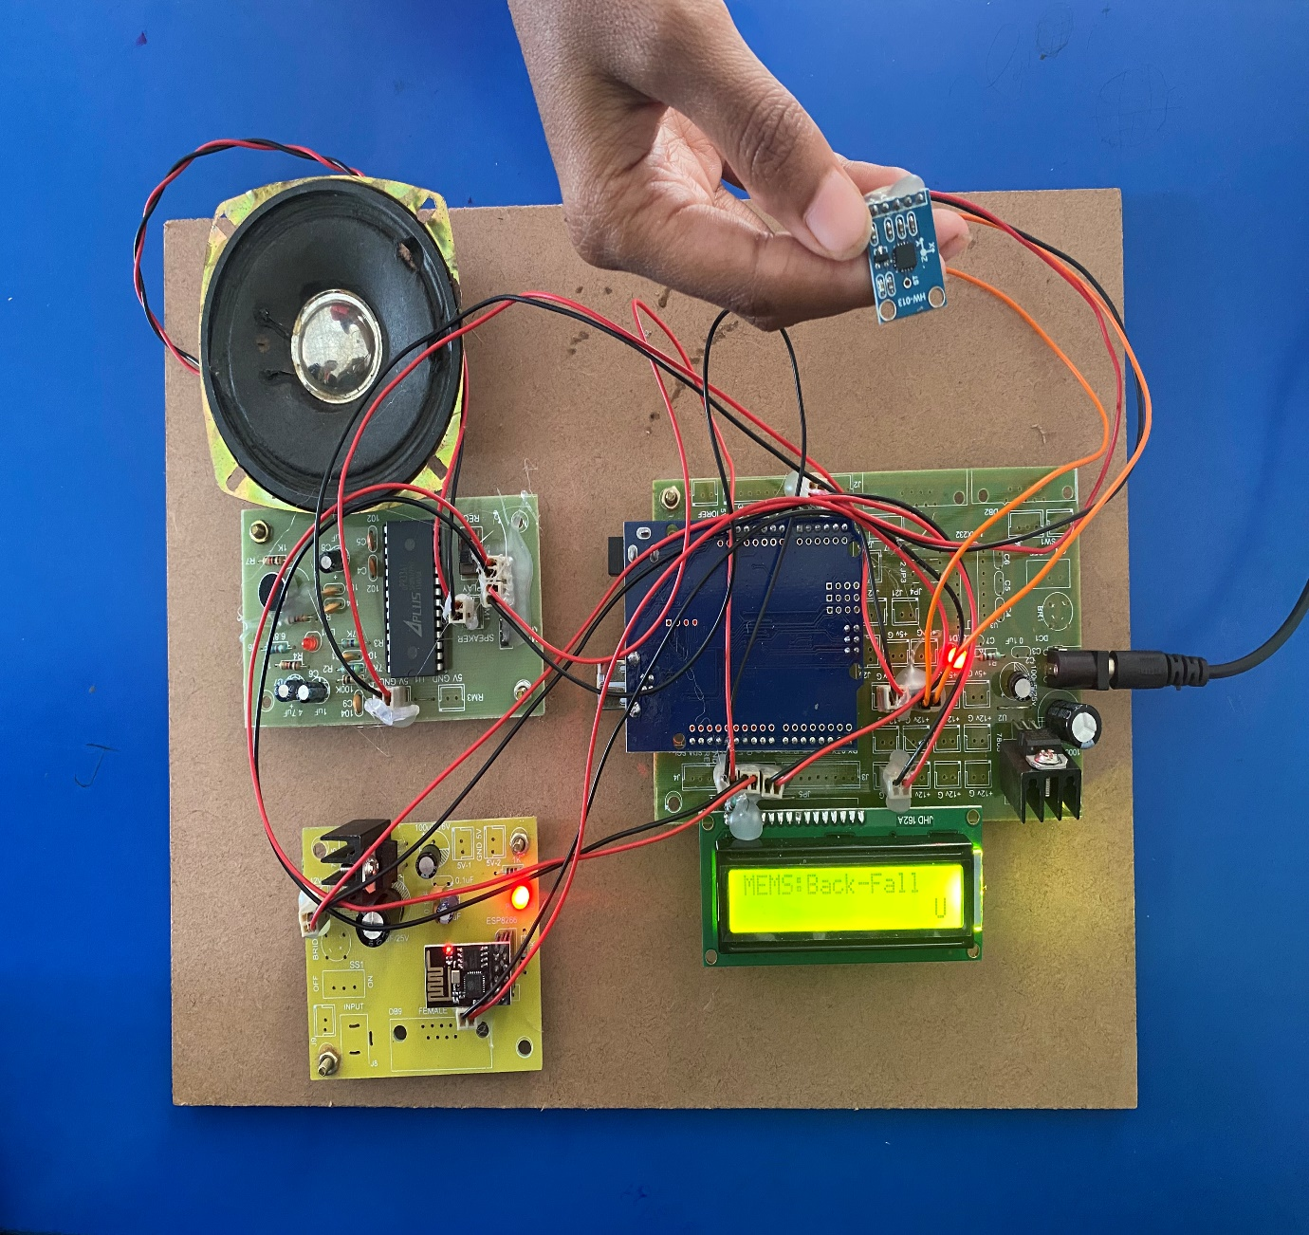

Figure 5.7 Back Fall Detected

**Description:** When a person falls backward then the sensor detects back fall.

38

## 

Figure 5.8 Right Fall Detected

**Description:** When a person falls towards Right then the sensor detects right fall.

39

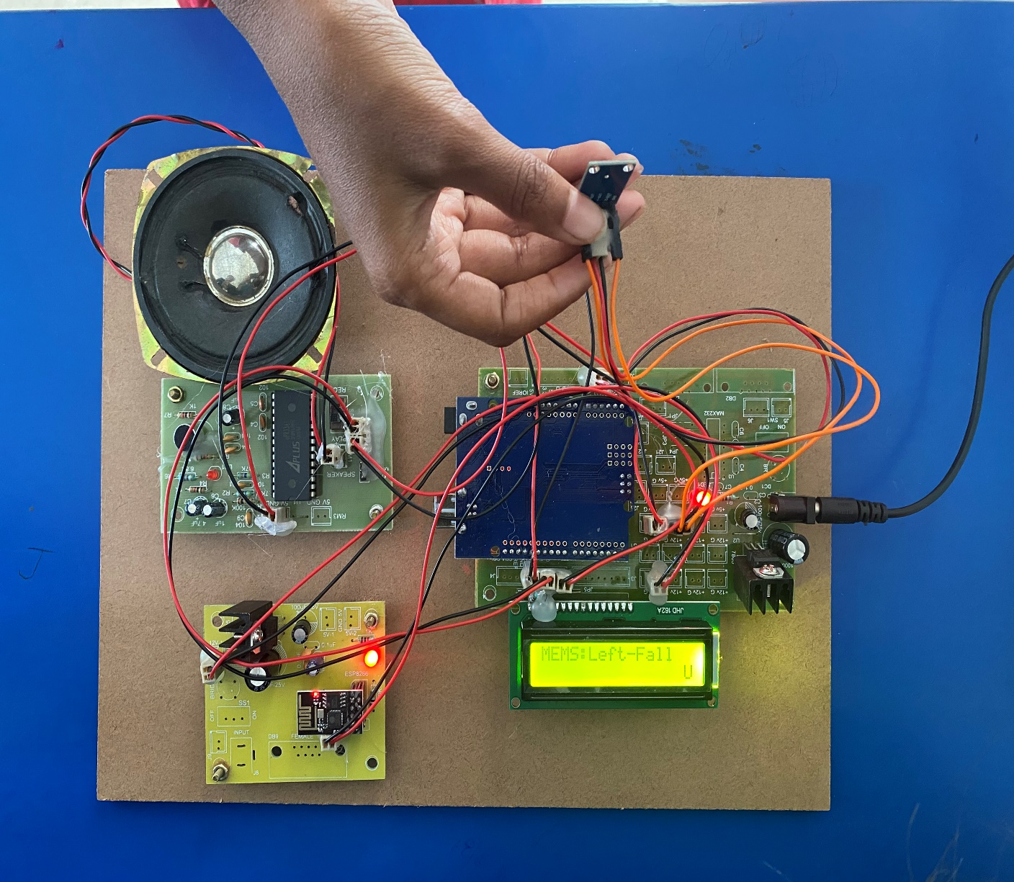

Figure 5.9 Left Fall Detected

**Description:** When a person falls towards Left then the sensor detects Left fall.

40

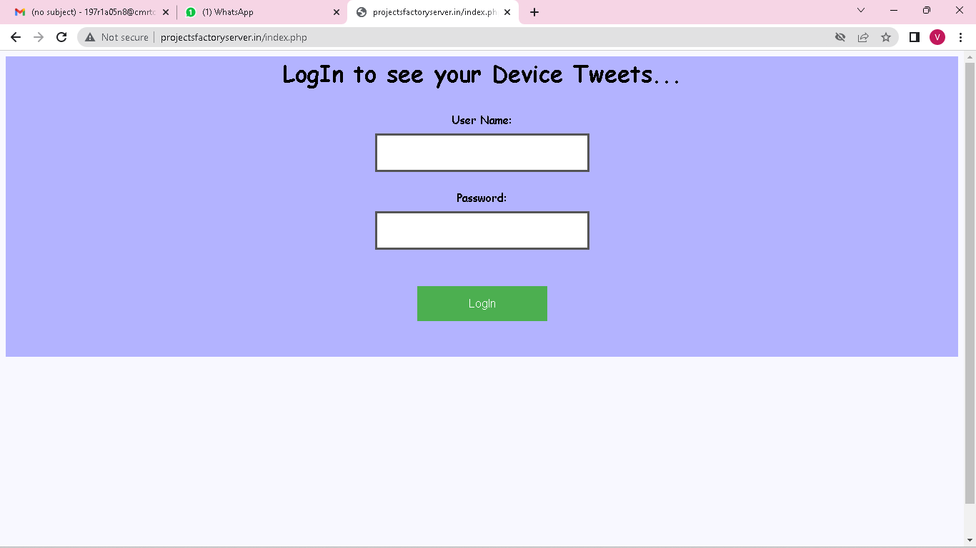

Screenshot 5.1 Login Page

**Description:** This is server login page. User should enter username and password to monitor the persons movements

41

## 

Screenshot 5.2 Entering Login Credentials

**Description:** User enters username and password to monitor the persons movements

42

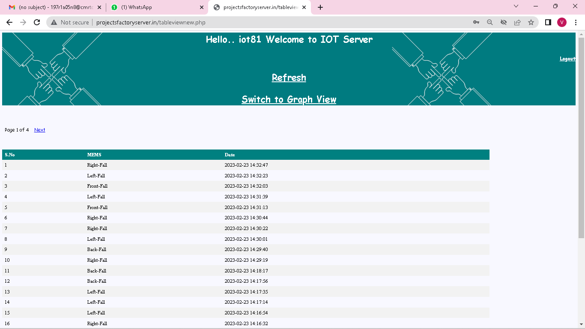

Screenshot 5.3 Iot Server Page

**Description:** This is the main page which displays the status of the person’s movements.

43

## 6.TESTING

**6.TESTING**

**6.1 INTRODUCTION TO TESTING**

The purpose of testing is to discover errors. Testing is the process of trying to discover every conceivable fault or weakness in a work product. It provides a way to check the functionality of components, subassemblies, assemblies and/or a finished product. It is the process of exercising software with the intent of ensuring that the Software system meets its requirements and user expectations and does not fail in an unacceptable manner. There are various types of tests. Each test type addresses a specific testing requirement.

**6.2 TYPES OF TESTING**

**6.2.1 UNIT TESTING**

Unit testing involves the design of test cases that validate that the internal program logic is functioning properly, and that program inputs produce valid outputs. All decision branches and internal code flow should be validated. It is the testing of individual software units of the application. It is done after the completion of an individual unit before integration. This is a structural testing that relies on knowledge of its construction and is invasive. Unit tests perform basic tests at component level and test a specific business process, application and/or system configuration. Unit tests ensure that each unique path of a business process performs accurately to the documented specifications and contains clearly defined inputs and expected results.

44

**6.2.2 INTEGRATION TESTING**

Integration tests are designed to test integrated software components to determine if they actually run as one program. Integration tests demonstrate that although the components were individually satisfactory, as shown by successfully unit testing, the combination of components is correct and consistent. Integration testing is specifically aimed at exposing the problems that arise from the combination of components.

**6.2.3 FUNCTIONAL TESTING**

Functional tests provide systematic demonstrations that functions tested are available as specified by the business and technical requirements, system documentation, and user manuals.

Functional testing is centered on the following items:

Valid Input : identified classes of valid input must be accepted.

Invalid Input : identified classes of invalid input must be rejected.

Functions : identified functions must be exercised.

Output : identified classes of application outputs must be exercised.

Systems/Procedures: interfacing systems or procedures must be invoked. Organization and preparation of functional tests is focused on requirements, key functions, or special test cases.

45

**6.3 TEST CASES**

**6.3.1 CLASSIFICATION**

|  |  |  |  |  |
| --- | --- | --- | --- | --- |
| Test case ID | Test case name | Purpose | Input | Output |
| 1 | Wi-fi | Activating the device | The user provides internet connection using mobile | Wi-fi ready. |
| 2 | Front Fall | To detect front fall | The user falls in forward direction | Front Fall detected. |
| 3 | Back Fall | To detect  back fall | The user falls in backward direction | Back Fall Detected. |
| 4 | Left Fall | To detect left fall | The user falls towards  left side | Left Fall Detected. |
| 5 | Right Fall | To detect right fall | The user falls towards right side | Right Fall Detected. |
| 6 | Login to server | To monitor the user’s movement | The user enters the wrong credentials | Login Failed. |
| 7 | Login to server | To monitor the user’s movement | The user enters the credentials | Login Success. |

CMRTC 46

**4. CONCLUSION**

##### 4. CONCLUSION & FUTURE SCOPE

##### 4.1 PROJECT CONCLUSION

##### 

##### As fall detection is considered to be the major challenge in domains like health care, especially in the cases of elder people, fall detection system has been developed based on IOT using MEMS sensor. The system is capable of continuous monitoring of the human body movement and these kinds of detection method uses some threshold value which is set with controller to detect a fall. The prototype can be tested for real time use and can be developed into a product that can be used for elder people and patients. Once the acceleration crosses the threshold value, the fall is detected and an alarm is generated. The system consumes less power and has more efficient. It also keep track of some of the biological parameters such as heart beat, temperature etc. This system is suitable for indoor as well as outdoor fall detection since both software as well as hardware are suitable for this purpose

##### FUTURE SCOPE

Despite continued research over many decades into preventing and predicting falls in elderly people, some factors are still unattended to. The concerns of various governments and the reputed organizations, such as the WHO (World Health Organization), regarding the increasing incidents of falls and their impact are enough to attract researchers to this field. However, some recent research has claimed to achieve the required accuracy in predicting falls, but still they are questionable because of their testing environment. Most of the researchers have not taken into account the perceptions of the actual users regarding what they expect from the product. National governments prefer to give funding for promoting research in this field so that the budget that is spent on after-fall services can be reduced. In the future, the researchers may focus on exploiting some of the principal observations stated in this paper. A hybrid approach of proper education, IOT techniques, and clinical support is expected to achieve real goals.

47

### 5. BIBLIOGRAPHY

##### 5. BIBLIOGRAPHY

##### 5.1 REFERENCES

[1] Hwang, J.Y., Kang, J.M., Jang, Y.W., Kim, H.C.: Development of novel algorithm and real time monitoring ambulatory system using Bluetooth module for fall detection in the elderly. In: Engineering in Medicine and Biology Society, IEMBS 2004, 26th Annual International Conference of the IEEE, vol. 1, pp. 2204–2207, September 2004

[2] B. Najafi, K. Aminian, F. Loew, Y. Blanc and P. A. Robert, "Measurement of stand-sit and sit-and transitions using a miniature gyroscope and its application in fall risk evaluation in the elderly", IEEE Trans. Biomed. Eng., vol. 49, no. 8, pp. 843-851, 2002.

[3]. National Institute ofNursing Research, Informal Caregiving Research for Chronic Conditions RFA, (2001).

[4]. E. Mattila, I. Korhonen, J. Merilahti, A. Nummela, M. Myllymaki, and H. Rusko, “A concept for personal wellness management based on activity monitoring,” in Pervasive Computing Technologies for Healthcare,2008. Pervasive Health 2008. Second International Conference on, 302008-feb. 1 20 08, pp. 32 –36.

48